Solidarity story –

Book in France for the Orphans of Bosnian war 1992-1995
I have two children. Son Amer (1987) and Daughter Sabina (1994). They could have lost their father during the brotherhood, but aggressive war in Bosnia and Herzegovina 1992-1995 because the question of living was not will I die, but when my time will come to die.
That is why I wanted, as a writer and a poet and freelance journalist wanted to show others: Bosniaks (Muslims), Croats (Catholics) and Serbs (Orthodox) that we all are humans and we can, for sure, live and make our lives better, if we are together.

Everything started during the war when I wrote some of mine strongest and heartful poems, just a night prior being wounded in Bugojno (city at the Middle Bosnia and Herzegovina, 120 kilometers west from my Sarajevo, where I was living since 1986 and during the war – my wife Amira is from Bugojno) and spent several days in comma at the Hospital in Zenica.
One of the poems is:

Jonathan Livingstone the Seagull

In their workshops
over and over again
they patched up the wings of my youth.
I will have them back
Rebuilt
Reassembled.
They will not be wings any more.
They will only be the expression
of something
that once upon the time was known as a voyage.
They will cover me with a tar
and display me for the world to see.
I foretell the future
My future and
their future.
....
I shall hold onto to my feathers,
They are mine.
----------------------------------------
Book of poetry "Amanet" (BiH, 1996)
Book of poetry Testament (France, 1998)

After recovering, I have decide that, after the war, I will dedicate my life to help children of Bosnia and Herzegovina, regardless the age, gender and ethnicity (nationality) because they could have lost their father as mine could have lost me.
So, everything after that belongs to History, if I may say. Namely, after publishing a book of poetry in Bosnia and Herzegovina titled “Amanet” and having a quite success within the Bosnia and Herzegovina cultural scene in Sarajevo, my home town and in Bugojno, where I met, by coincidence Mr. Michel Neveu back in 1997 in Bugojno, a Head of NGO “Promethee 71” (presented by Michele Neveu and Benoit Raphael) from St. Egreve (Grenoble), France and story started.

First, Michel was introduced to some of my poems with which he was delighted, and he said that he would like to recommend my poetry for the publishing by Artootem, Publisher from Annecy, France. Although being surprised being unknown person for the French cultural literature scene, I got enough courage to tell him that I agree, but under one condition: That all the income of the selling of the book goes to the Bosnia and Herzegovina orphans, regardless, their age, gender and ethnicity (nationality). Also, that he will be the guy (his NGO) who will coordinate with everything in France. We signed a contract on 19.09.1997¸and translators from France (Fatima Pirić, Christiane Dupont and Faris Rujanac) and Belgium (Edouard d’Aoust) begun their work in translation of the book of poetry. It took them a year.

While the book was translated, myself have tried to organize a contacts with all targeted people in Bosnia and Herzegovina to make children more focus on joint solidarity work on leaning on each other, so started to contact, first official institution – municipality of Bugojno and Association from Sarajevo “Education build Bosnia and Herzegovina) led by my dear friend Jovan Divjak. At the beginning I had problems with municipality leaders of Bugojno because, after the war in unorganized country (I call it still “organized anarchy”) they wanted to manipulate with me and ask me to take with me on vacation to France some of their children from the Municipal council leaders which I rejected and I directly contacted local Catholic priest and Muslim imam priest to help me to find a kids for helping them. They did but let’s focus first on the promotion of the book.

My first trip out of Bosnia and Herzegovina, after the war, was in 1998, for the purpose of the promotion of the Book of poetry “Testament” in France during 15 (fifteen) days organized promotional tour around South-West France. The preface of the book was written by the famous Abbe Pierre who honored me with his words considering me as his brother within human civilization.
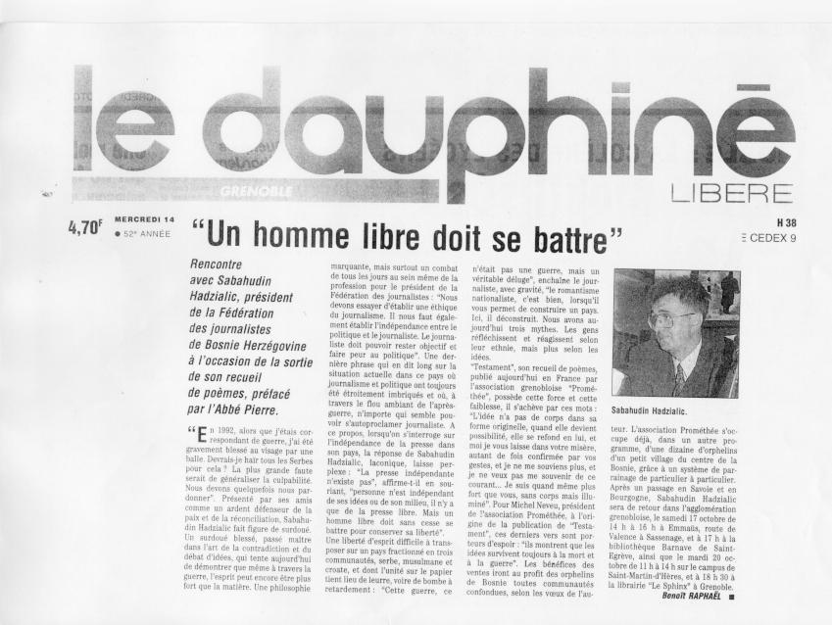
Having in mind that in that “after the war” time there was no flight connection between BiH and France, I went to airport in Split, Croatia and, together with my wife, flew from Split, via Paris, to Lyon in France where Michel Neveu was waiting for me at the airport. Those fifteen days of promotional tour for my book when I met hundreds of people from France and some other EU countries such as Spain and Belgium, including some refugees from Bosnia and Herzegovina were my best experience ever in my life knowing that this solidarity work of mine will help orphans of Bosnia and Herzegovina. Why? Because, I wanted to show, that, regardless their late fathers who were fighting against each other in the war, the new generation must and will show that they can overcome the wounds of war and start new joint life of solidarity and respect.

First promotion of the book was at Grenoble in Grenoble International at 6.30 p.m. Magnificent promotion thanks to people from Promethee (Michel Neveu, Aude and Emma Cuenot as well as Lucette Ribet) and Deputy Mayor of Grenoble who has opened the Promotion that night on October 9, 1998. Next one was on 10.10.1998 in the Theatre nearby DECITRE bookshop in Annecy (where the place of my Publisher was). I was honored to be a guest of honor of Dr. Joelhe from Annecy in her house after the promotion. Next promotion was on Monday, 12.10.1998 at Emmaus Community in Bourg. On Tuesday, October 13, 1998, Sabi had a promotion in city of TOURNUS in a High School and in the Secondary school. In the evening promotion was held at the Cinema "La Palette" after the presentation of the movie of Ademir Kenovic called "Perfect Circle". This time the host was Dr. Paul Polis and his family. On Wednesday, October 14, 1998, promotion was in city of MACON, having promotion at the High school as well as in the Bookshop "Cadran Lunaire".

I was signing a lot of books while my publisher was selling them for the benefits of Bosnia and Herzegovina children. Gave an interview to the local newspapers back in Annecy and Grenoble and continue with the promotional tour. On Thursday, October 15, 1998, was in the city of CHALON SUR SAONE, having promotion at "La Mandragore" bookshop. On Saturday, October 17, 1998, went back in GRENOBLE and had a promotion at EMMAUS COMMUNITY in SASSENAGE at 2 p.m. After that the promotion was held within the Day of Poetry in ST EGREVE at BARNAVE'S library at 4 p.m. On October 19, 1998 (Monday), the Promotions were held at the Stendhal International High School at 10 a.m. and after that, during the evening at the "Tonneau de Diogene" cafe (readings of poems about tolerance and peace) at 8.30 p.m. The host was Laurent Marielle- Trehouart- Charge de mission of the Maison de la Poesie Rhone- Alpes and Xavier, French Artist. Also, Sabi gave an interview to the Radio France International in Grenoble.

Promotion was held as well at the University Campus in Grenoble on Tuesday, October 20, at 12.30 a.m. at Arthaud Campus bookshop and then with the Drugi Most NGO outside of the bookshop. During the day I visited Maison de la Poesie Rhone- Alpes at Saint Martin d'Herese and signed the memory writers book. At the evening, the Promotion was held at "Le Sphinx" bookshop at 6.30 p.m. Wednesday, October 21, 1998. Last day of the promotion. Last promotion was held at J.Jacques ROUSSEAU bookshop in CHAMBERY at 5 p.m. After that, Sabi was interviewed by the local journalist from Chambery for the daily newspaper. On Thursday, October 22, Sabi with his wife Amira went, extremely satisfied, back home from airport SATOLAS (Lyon to Bugojno, Bosnia and Herzegovina).

Rock'n'roll will never die having in mind a task in front of myself in regards realizing: 1. choosing a orphans from BIH and 2. taking them on summer vacation to Grenoble and teaching them tolerance, solidarity and peace.

It has arrived towards realization during the summer of 2001. The money collected out of the selling of the book (15.000 Euros) was enough to take kids of the age between 10 and 14 to Grenoble, France from Bugojno (as write above, local Priests (Musim and Catholic one helped me to choose real orhpans and not family members of the municipal leaders): Anica Radić, Miranda Gavrić, Miroslav Budimir, Miran Gavrić, Saldin Opardija, Amel Bambur, Haris Ćurić, Mirza Idrizović, Munib Muratspahić and Elvedin Dautbegović and from Sarajevo (to choose the orphans received a help from Mr. Jovan Divjak and Association “Education builds Bosnia and Herzegovina”: Anida Hasanović, Ivana Mujanović, Esmer Hodžić, Damir Hodžić and Fehim Selimović.
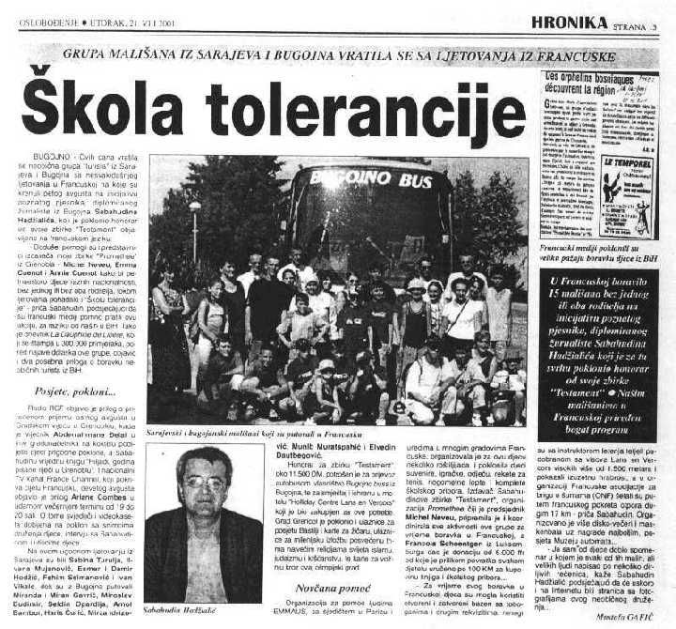
At the beginning of August of 2001, I hired a bus and organized 2 weeks’ vacation for the orphans from Bosnia and Herzegovina during which they have been staying in Motel (I took my family as well with me and as well Saša Mujezinović as the last year students of the Social work Department within Faculty of Political sciences of the University of Sarajevo to coordinate the children and one parent of two children from Bugojno, Mrs. Marica Gavrić) upon the hills above Grenoble, France. Children were, during 14 days of stay, playing tennis, travelling around, attending “School of tolerance”, visiting NGO’s, receiving gifts, football and basketball, travelling bikes, climbing, swimming in the pool and paragliding as well.

Solidarity within its fullness has shown that they can play, become friends and continue the friendship even after their fathers were shooting to each other during the war. New dawn is coming and Sabahudin Hadžialić wanted to give an example how that can work out. In the same time, other people helped Sabahudin, aside of the Publisher and NGO “Promethee 71” from France among which the best help was from Michel Neveu and Aude Cuenot. A friend from Luxembourg, Francois Schoentgen donated 750 Euros and Sabahudin gave to each kid 50 Euros for the books in school as well. Sabahudin also gave each kid a bicycle as a gift to have as the memory for the tolerance and solidarity trip in France, back in 2001.

The biggest gift to Sabahudin was that children will never forget that vacation and they gave Sabahudin a scrapbook with their memories on the last day of the vacation which is the most important gift I have ever got in my life. A lot of newspapers, TV stations in France and in BiH was reporting about this trip and one of the headlines in Croatian newspaper said: “If Everybody would do it like Sabahudin did”. That was a goal of solidarity from Sabahudin Hadžialić side – to show others that “good gives good” and we can only go through this short life as humans first, and then everything else we want to be. But, the humans first.

--------------

Author of the solidarity story – translation in English from BHSC – joint language: Bosnian, Serbian, Croatian and Montenegrin by the author

Prof. Sabahudin Hadžialić
Assoc. Prof. Dr. & Dr. Honoris Causa
30.7.2019

Details about that humanitarian, solidarity story are here: https://sabihadzi.weebly.com/humanitarni-rad_humanitarian-work.html (photos, articles, movies, gratitudes).
In Bosnian, Croatian, Serbian and Montenegring (Joint language) „Amanet“ translated in English is: behest.
PBS Bosnia and Herzegovina – main public TV station: https://vimeo.com/14445609
I was working between 1994 and 1997 within NGO AICF/USA as a translator and Program Officer and between 1998 and 2001 within OSCE BiH as translator, Program Officer and Deputy director for BiH Elections Implementation
Abbe Pierre (1912-2007) - https://www.biographyonline.net/humanitarian/abbe_pierre.html
History of the promotional tour: http://sabahudinh.tripod.com/france98/
Info (articles, videos, photos): https://sabihadzi.weebly.com/france-1998_2001.html
Info (details): http://grenoble2001.blogspot.com/
Info (detals): http://grenoble2001.blogspot.com/2009/12/fotografija-same-govorephotos-speaks.html

