Dr. Swaleha Sindhi

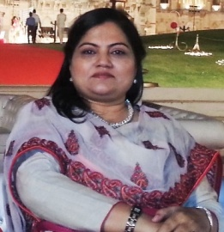Dr. Swaleha Sindhiis Assistant Professor in the Department of Educational Administration, The Maharaja Sayajrao University of Baroda, Gujarat, India.She is in the Editorial Team of Eurasia Review. Besides writing columns on education theme in newspapers, she has to her credit more than fortyresearch articles published in national and international journals and magazines. Dr.Sindhi’s doctorate is in the area of Quality Assurance System inSchools. Her areas of interest in research follows two core themes; Quality Assurance in Education and Educational Management, besides other areas like Education policies, Gender and Education, Educational Leadership and Economics of Education. Dr. Sindhi is recipient of two prestigious awards for teaching; The Best Teacher Award for excellence in teaching (2007)and Shri K.L.Sidana Award of excellence for contribution in Leadership development (2015). Currently she is the Vice President of Indian Ocean Comparative Education Society (IOCES). She can be contacted at; swalehasindhi@gmail.com.

PR
DIOGEN pro kultura
http://www.diogenpro.com

