Petya Gleridis, Bulgaria

confetti in the hair
of the old cherry
nettle weaving swings in its skirts

konfeti u kosi
stare trešnje
u svojim suknjama kopriva tke ljuljačke

*

gentle rain
touching the surface
love breathing upon the water

blaga kiša
dodiruje površinu
ljubav diše na vodi

*
a serpent in the bosom
the wind rippling the lake
kissing the bank gently

zmija u njedrima
vjetar mreška jezero
ljubeći nježno obalu

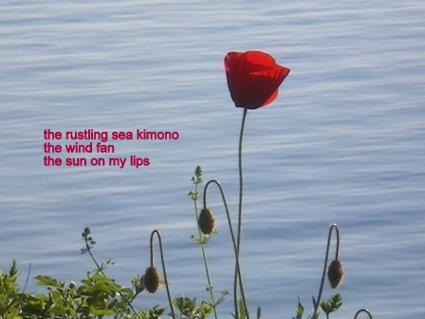
HAIGA:

the rustling sea kimono
the wind fan
the sun on my lips

šuštavi kimono mora
lepeza vjetra
sunce na mojim usnama

*

near the pond
crickets hopping
in tune with singing grass

pored ribnjaka
zrikavci skakuću
u skladu s pjevajućom travom

*

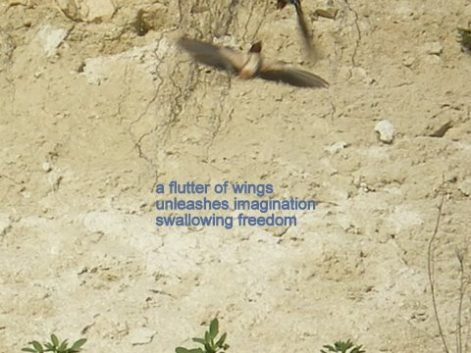

HAIGA:

a flutter of wings
unleashes imagination
swallowing freedom

treptaj krila
oslobađa maštu
guta slobodu

*

in fluffy captivity
my feet are
whispering dandelions

u paperjastom ropstvu
moja stopala
šapću maslačcima

*
the curls of the sunset
tangled
orange blue

kovrče zalazećeg sunca
zapletene
narančasto plavo

*

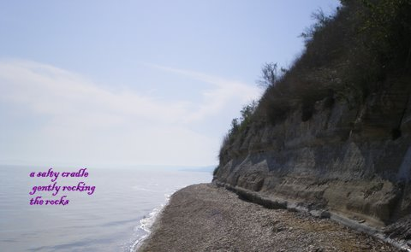
HAIGA

a salty cradle
gently rocking
the rocks

slana kolijevka
nježno ljulja
kamenje

*

grasshopper feast and grass arrows
behind a moon shield
the summer’s declining days

gozba skakavaca i strelice travki
iza mjesečeva štita
sve kraći ljetni dani

*
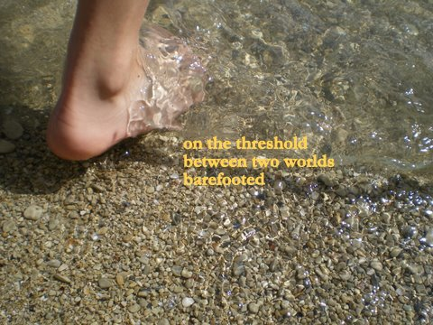
HAIGA:

on the threshold
between two worlds
barefooted

na pragu
između dva svijeta
bosonoga

PR
DIOGEN pro kultura
http://diogenpro.com

