Peter Tase
Nakhchivan: Feeling the pulse of Azerbaijan’s History
With the closing session of the 7th Global Forum of UN Alliance of Civilizations (held on April 25-27, 2016) my second visit to Baku was coming to an end. However - after my five nights spent at the Boulevard Hotel Baku located on Khagani Rustamov Street - during my last breakfast at the main restaurant (on the first floor), I was joined by Mr. Samir Aliyev, Boulevard’s food and beverage manager, who shared with me a mouth watering smoked salmon [1] accompanied by a bread basket filled with delicious eppek, tapi and dari jadi, [2] with a side of homemade Apricot Yoghurt and Yarpiz küküsü. [3] Such a unique Azerbaijani breakfast at the Boulevard was the early opening of Nakhchivan’s Castle Gate to welcome me for the second time (just a few hours after leaving Baku) into its quarters, a place where the cultural and archeological heritage of Azerbaijan is appreciated and placed at the center stage.
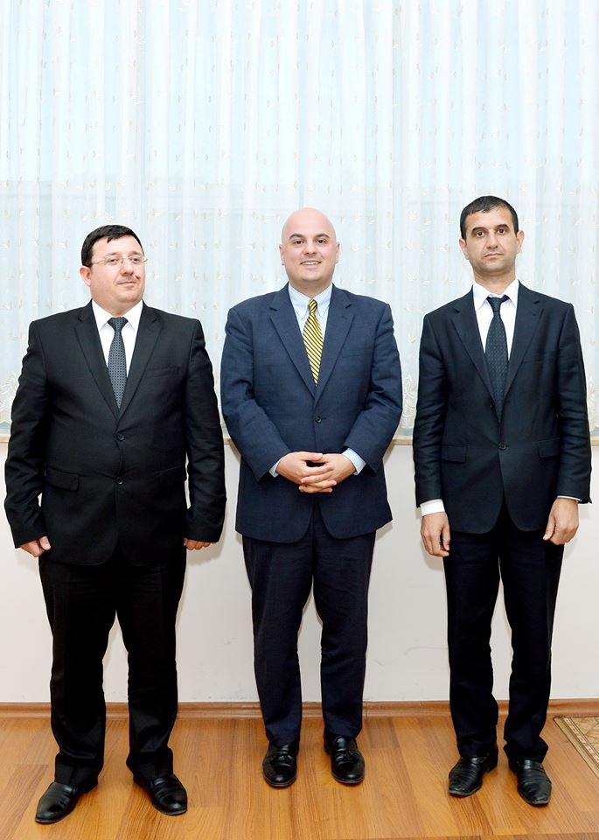
Peter Tase and Tural Safarov in Nakhchivan. May 2016

After savoring such a five star breakfast together with Mr. Aliyev, without losing any of my precious time, I hustled into a London Style taxi-cab so that I could fly out of the Heydar Aliyev International Airport (terminal 2) - with an Azerbaijan Airlines Aircraft - directly to the Autonomous Republic of Nakhchivan: the land of Alinjagala Castle, Momuna Khatun Tomb and the home of: 250 public schools, dozens of museums and of two first class universities equipped with modern campuses. [4]

The plane departed from the Heydar Aliyev International Airport and in approximately two hours later it landed at the recently inaugurated Nakhchivan International Airport, nearby Nakhchivan City; the airport itself is a modern structure that could accommodate more than 460 passengers per hour.
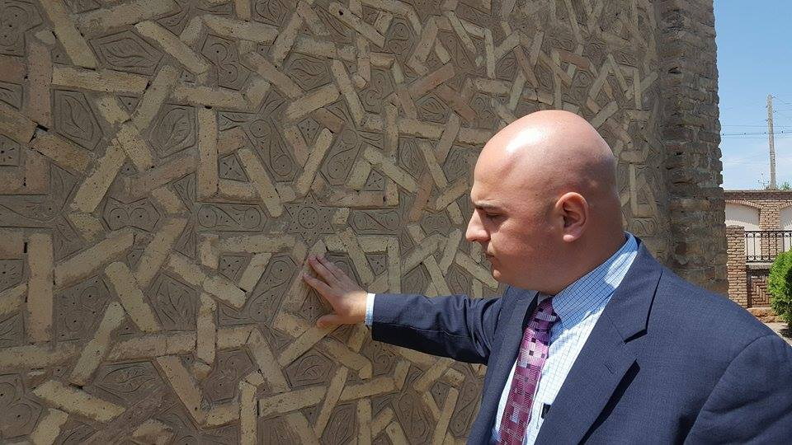
Peter Tase in Momuna Katun Tomb. May 2016.

The Autonomous Republic of Nakhchivan, an integral part of Azerbaijan, is perhaps the oldest settlement of Azerbaijani nation. According to the Cultural and Archeological discoveries it is demonstrated that people have been living in this region since the Stone Age. Research has shown that Nakhchivan had suitable conditions and a favorable climate so that primitive tribes (men and women) could take up residence in this territory during the period of Mustye Civilization that dates back to 100 to 35 thousand years ago. The toponymy of Nakhchivan’s ancient name has a few etymological explanations. Some historians and geographers of antiquity and late antiquity, based on the old myths and legends wrote that, Nakhchivan was built in 1539 B.C. The earliest information published about the city belongs to Josephus Flavius (1st Century B.C.), a renowned historian, and by the Greek Geographer Claudius Ptolemy (2nd Century AD). For the first time, the name of Nakhchivan has appeared as Naksuana in the book of “Geography” written by Claudius Ptolemy. In the years circa 50 B.C., based on Arabian and Persian sources, the name of the city has been written as Neshave, Negchuan (Nekhchuan, Nekchuvan, and Nekhchevan). In some other sources is mentioned the name “Negshi-cahan” within the context of Nakhchivan’s toponymy it meant: “the adornment of the world”. The origin of Nakhchivan’s toponymy is related to the ‘world storm’ that involves the mythical Prophet Noah. According to the ancient scholars’ observations, the word Nakhchivan means the land of Noah.
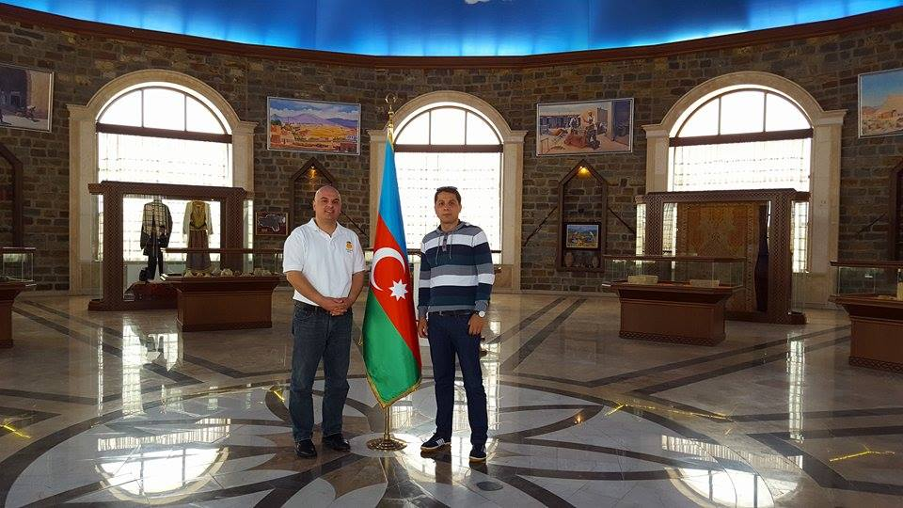
Peter Tase in Nakhchivan Castle. May 2016.

In the first centuries of the I Millennium B.C., Nakhchivan was part of the Manna and Midiya, empire of Ahamanilar and Athropatens and later on was part of the Sasanian Empire in the 3rd Century AD; it also became part of the Arabian Caliphate during the VII-IX Centuries, and was included into the territories of the Saci, Salari and Revvadi authorities.
The remnants of such an ancient period are reflected at the museums located in the city of Ordubad which is an important treasure of the world history and archeology. The region of Ordubad takes every foreign visitor at a high level of immersion and understanding of the Azerbaijani Mythology, History and Cultural Wealth, Archeological Treasures and Values.
Seljug Sultan Alp Arslan had established control over the territory of Nakhchivan after destroying the State of Revvadi and immediately decided to build his palace in this emblematic region of Azerbaijan. Nakhchivan became the capital of the Azerbaijani State of Atabeyler that was in power between the third through the seventh decade of the XII Century. In this period Nakhchivan had a great development and it became one of the architectural centers of Eurasia.
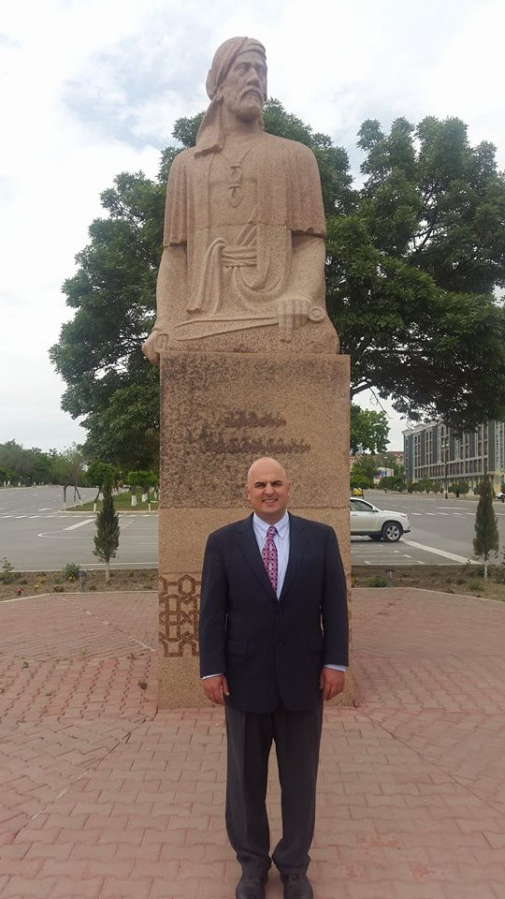
Peter Tase in Nakhchivan, May 2016.

During my visit in Nakhchivan, I stayed at Tabriz Hotel, located at the center of Nakhchivan City in front of the Serq Qapisi Newspaper Offices. Tabriz Hotel is a five star hotel built by U.S. standards, a 13 floors high rise that has recently become as the symbol of the city, equipped with a top notch panoramic restaurant; 95 rooms (54 standard rooms 22 suites, 18 junior suites and one King suit), a SPA service and in-door Pool Amenities. The interior design of the rooms at Tabriz Hotel is led by renowned international interior decorators and the stylish private restrooms on every room are only seen at the Kohler Design Center in Wisconsin. Moreover, breakfast at Tabriz Hotel is a symbiotic combination of western cuisine with locally grown delicious ingredients. Dried fruits such as the famous Ordubad Apricots [5] and the locally grown almonds, fresh spices, tomatoes and green peppers are some of the tastiest organic products one could find in the world today. During my six days at Tabriz Hotel, the special preparation of traditional food recipes of Nakhchivan were an epicurean immersion that ought to be remembered forever: for lunch I had: Sumaxli Şorba Soup made with Sumach Split Peas, small onions, roasted bulb onions with rice and alycha (plums).
For dinner I had Dolma made of apples, roasted red meat with onions and coriander; locally made Yogurt infused with locally grown organic herbs accompanied on the side by an irresistible slice of high quality Salami made by Meat and Meat Products (MM LLC), a local company of Nakhchivan that makes high quality meat products that are destined to international markets at over twenty European and Asian countries.
In addition to being exposed to Nakhchivan’s exquisite cuisine, I spent all my time visiting Azerbaijan’s National monuments of Gulustan Tomb, Momuna Khatun Tomb, Garabaghlar Tomb, the Open Air Museum (nearby the Momuna Khatun Tomb), the Khan Palace, the State Historic-Architectural Museum (an architectural piece of remarkable importance due to its structure and construction materials that were used), as well as the emblematic museum of J.Nakhchivansky, a military leader of international importance. Additionally, my second visit to the ancient region and city of Ordubad was memorable; visiting the Qeysariyya Museum was truly an unparalleled experience where one could feel the pulse of Azerbaijani History. Viewing the archeological treasures at the Qeysariyya Museum is very common for visitors to take an imaginary voyage into the ancient times and civilizations that inhabited the current Azerbaijani territories. Returning to such a special historic Azerbaijani land, joined by the Editor in Chief of Şərq Qapısı (Sharg Gapisi) Newspaper Mr. TURAL SƏFƏROV was an overwhelming emotion.
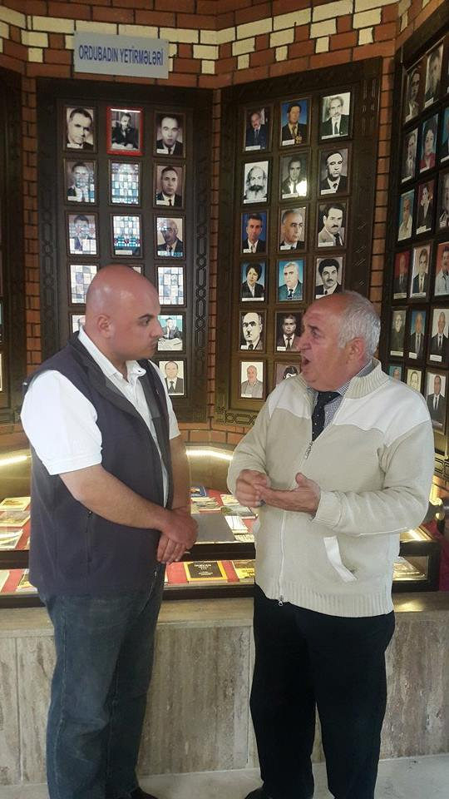
Peter Tase in Ordubad, May 2016.

We traveled through the main highway, a wide and spacious, paved road, of Western European standards built under the leadership and administration of Supreme Assembly Chairman Vasif Talibov. Our road to Ordubad introduced me once again: to the majestic beauty of geological terrains and formations across Nakhchivan, the beautiful grassy meadows shadowed by majestic mountains, intertwined with crystal water creeks and prairies adorned by hundreds of grass fed sheep, cows and rare wild birds. The mountain range that runs on the left side of the road from Nakhchivan city to Ordubad is a perfect landscape to have Hollywood cinematography leaders send a Crew of videographers and set the stage for future action movies that could very well take place in this gorgeous part of Azerbaijan. This region of Azerbaijan is very similar to the mountain ranges of New Mexico and Colorado, their shape is somewhat similar to the Sangre de Cristo Mountains, but the colors, geological layers of Nakhchivan’s mountain ranges are much more compelling, diverse and attractive.
After a one hour and half ride from Nakhchivan city, we arrived in Ordubad, the city of seven ancient streets, where every street has a mosque, an underground creek of fresh water and a sycamore (maple) tree. Since the early years of the spread of Islam, mosques in Ordubad have never had minarets because the city itself is located at a mountain cliff and it isn’t necessary for the local Imams to stand on the balconies of the minarets in order to loudly pray and make religious announcements. Ordubad, Azerbaijan’s ancient city, has three world class museums, one of them is Qeysariyya Museum which we visited accompanied by its Director Mr. Bağırov Vilayet. Mr. Vilayet provided a well structured introduction about the history of the museum, gave an overview of the most important cultural, military and historical figures of Ordubad and Azerbaijan. My conversation with Mr. Vilayet was very fruitful; it provided a well rounded introduction to the ancient sites and history of Ordubad as well as the city’s recent history including a number of memorable visits paid by Heydar Aliyev during the early 1990s in this region of Nakhchivan.
For lunch we tasted traditional meals of Ordubad: Kalam Dolmasi made with cabbage, diced and roasted meat with onions and other vegetables; Dolma made of eggplant, peppers and tomato; Eggplant Soyutma [6] with a bowl of fresh yoghurt (infused with locally grown herbs) on the side. I also tried some Kelempuz, Roasted Truffle Mushrooms and of course I could not leave Ordubad without trying the luscious shami kabab.
Ordubad’s cuisine combined with its fresh alpine climate, majestic mountainous views, religious monuments, its characteristic urban architecture; its hardworking people and its mythical spotless clean streets, make this region of Azerbaijan a unique place to visit where foreign visitors will always feel at home.
On the evening of May 1st, I left the ancient and mysterious city of Ordubad with high hopes to return again and continue to further explore its impressive ancient history and traditions, its cultural peculiarities and its highly valuable historical sites where the voices of rare birds awaken the pulse of Azerbaijani History.
Notes:
[1] Chef Samir Aliyev had prepared a smoked salmon that was as good as the smoked salmon prepared by the U.S. renowned Chef Mathew Wiltzius at the Lockwood Restaurant and Bar in Chicago; I was truly impressed. I happen to visit Lockwood for business meetings only a few months before my trip to Baku.
[2] Two traditional breads that are only baked in Nakhchivan, they are also called: eppek in Nakhchivan.
[3] Kuku of horse mint (Yarpiz küküsü)
[4] Nakhchivan State University (has the largest university campus throughout Azerbaijan) it is led by Chancellor Məhərrəmov Saleh Heydər Oğlu (http://ndu.edu.az/az/content/80/);
and the Nakhchivan University that is led by Chancellor Prof. Dr. İsmayıl İsrafil oğlu Əliyev (http://nu.edu.az/index.php?option=com_content&view=article&id=204:ismay%C4%B1l-%C9%99liyev&catid=9:%C9%99m%C9%99kda%C5%9Flar&Itemid=591&lang=az)
[5] The Apricots of Ordubad were widely exported to Moscow and throughout the Soviet Union during the second half of the XX Century. Ordubad has a wealth of medicinal herbs in addition to the sweet peaches, pears, grapes and apricots. Ordubad is also known for walnuts and plane trees.
[6] Eggplant Soyutma is cooked in embers, peeled and put into plate. Onions are cut and slightly roasted, cut tomatoes are added and cooked until the water is steamed out and added on the eggplants, Yogurt and garlic can also be served.

PR
DIOGEN pro kultura
http://www.diogenpro.com

