

KONJI

HORSES

Ilustrator: Ljubomir Radovančević, Croatia;
Hajge: Učenici 4a razreda OŠ Novska, grad Novska, Mentorica: Jasna Popović Poje

Autori/Authors: Robert Kania, Poland; Krzysztof Kokot, Poland; Tomislav Marijan Bilosnić, Croatia; Mirko Varga, Croatia; Predrag Pešić-Šera, Serbia; Željko Špoljar, Croatia; Darinka Slanovec, Slovenia; Maria Tirenescu, Romania; Ljubomir Radovančević, Croatia; Marija Pogorilć, Croatia; Robert Davey, England; Rudi Stopar, Slovenia; Vesna Milan, Croatia; Rosa Clement, Brazil; Smilja Arsić, Serbia; Nada Jačmenica, Croatia; Ernesto P. Santiago, Philippines; Zoe Savina, Greece

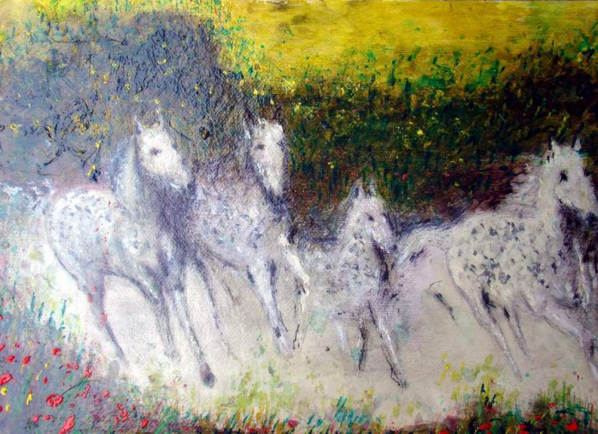
Ljubomir Radovančević, Zagreb, Croatia
*

old village
under the horse's hooves
clouds of dust

staro selo
pod kopitima konja
oblaci prašine

Robert Kania, Poland

*

galloping horses-
the wind entangled
in dispelled manes
konji u galopu-
vjetar upleten
u raspršenu grivu

**

a Gypsy camp-
the glow of fire in the eyes of horses
romski kamp –
sjaj vatre u očima konja

Krzysztof Kokot, Poland

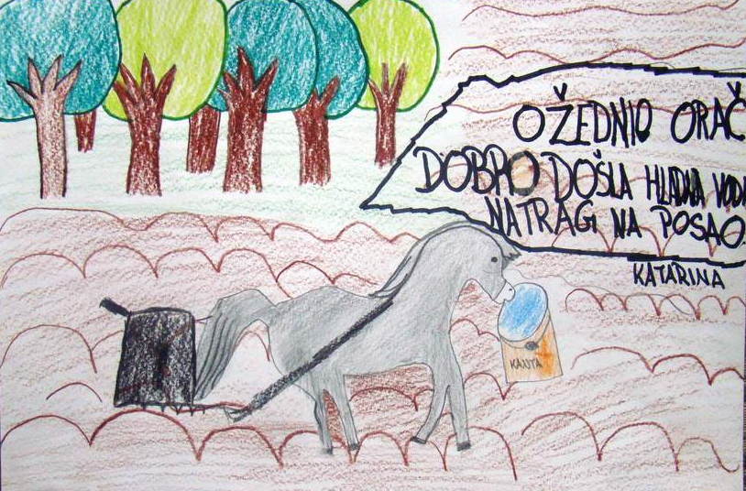
Katarina Maršić, 4a, OŠ Novska, Novska, Croatia
Mentor: Jasna Popović Poje
*

Kakva svježina.
Pored nas u galopu
projuri konj.

Such freshness.
Rushing close to us
a horse in gallop.

Tomislav Marijan Bilosnić, Croatia

*

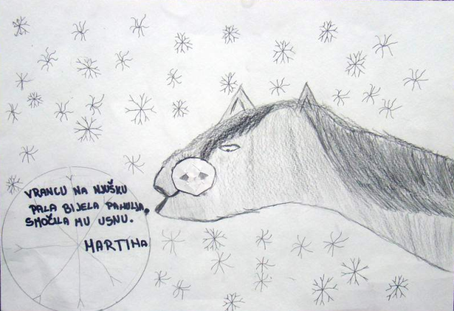

Martina Iličić, 4a, OŠ Novska, Novska, Croatia
Mentor: Jasna Popović Poje

*

očev sprovod -
kao jednogodišnje dijete
pamtim samo susjedove konje

my father's funeral -
as a year old child I remember
the neighbour's horses only

Mirko Varga, Croatia

*

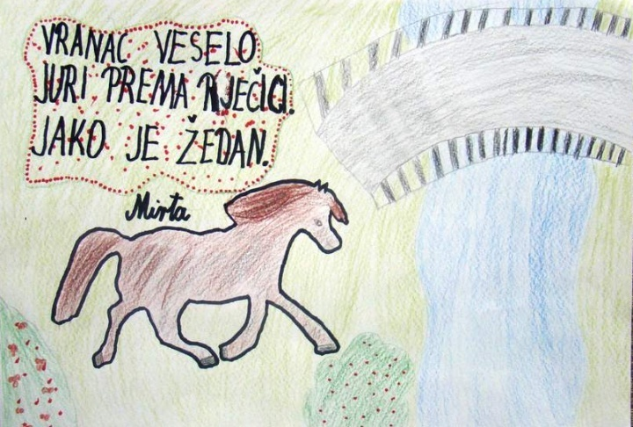
Mirta Špoljarić, 4a, OŠ Novska, Novska, Croatia
Mentor: Jasna Popović Poje

*

Prema zabranu
seljak na konju
nosi motorku.

Towards a reserve
farmer on a horse
carrying a chainsaw.

Predrag Pešić-Šera, Serbia

*
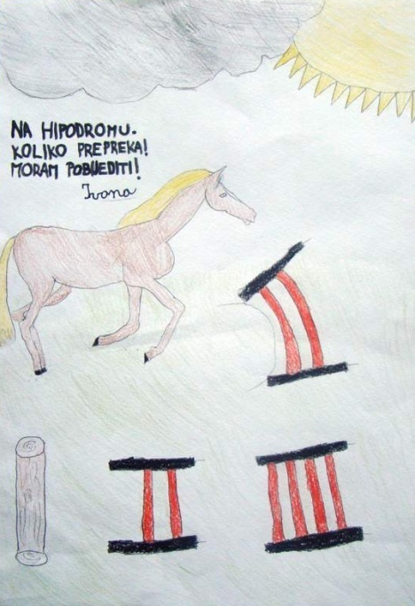
Ivana Groznica, 4a, OŠ Novska, Novska, Croatia
Mentor: Jasna Popović Poje

*

konj u galopu
s dječakom na leđima
bliži se nebu

a horse in gallop
with a boy on his back
gets close to the sky
Željko Špoljar, Croatia
*

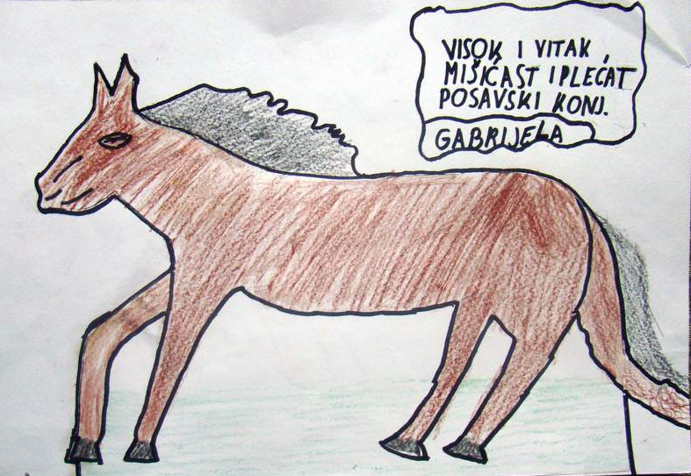
Gabrijela Kivač, 4a, OŠ Novska, Novska, Croatia
Mentor: Jasna Popović Poje
*

preden leže
si mrzle roke greje
z božanjem konja

before going to bed
she warms her hands by
caressing the horse
Translated by the author

pred spavanje
hladne ruke grije
milujući konja

**
tih večer
edini prijatelj
moj konj

silent evening
the horse
my only friend
Translated by the author

mirna večer
konj
moj jedini prijatelj

Darinka Slanovec, Slovenia

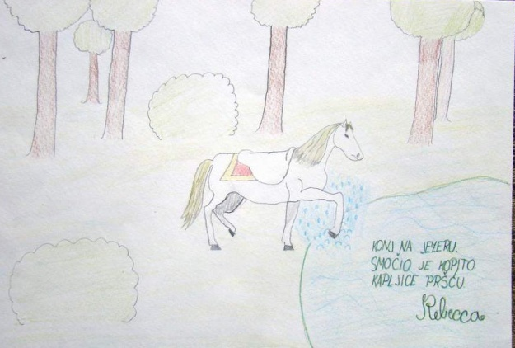
Rebecca Bjelanović, 4a, OŠ Novska, Novska, Croatia
Mentor: Jasna Popović Poje

*

calul bătrân
îşi scutură coama –
cad frunze galbene

old horse
shakes his mane –
the yellow leaves fall
Translated by the author

stari konj
protresa grivu –
žuto lišće pada
**
mânzul paşte
pe coama dealului –
o adiere

colt grazes
on the hill top –
a breeze
Translated by the author
ždrijebe pase
on vrhu brijega -
povjetarac
Maria Tirenescu, Romania

*

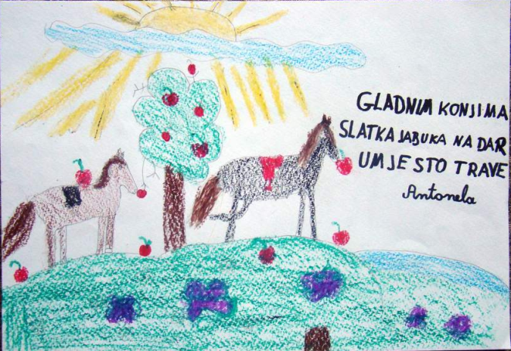
Antonela Rajković, 4a, OŠ Novska, Novska, Croatia
Mentor: Jasna Popović Poje

*

I griva ovog vranca
upija svom snagom proljetnu
mjesečinu

The mane of this black horse
with all its strenght inhales
the spring moonlight

**

Velike dveri
treba otvoriti toj kobili,
reče veterinar

The large gate
should be openeded for this mare,
said the veterinarian

Ljubomir Radovančević, Croatia

*

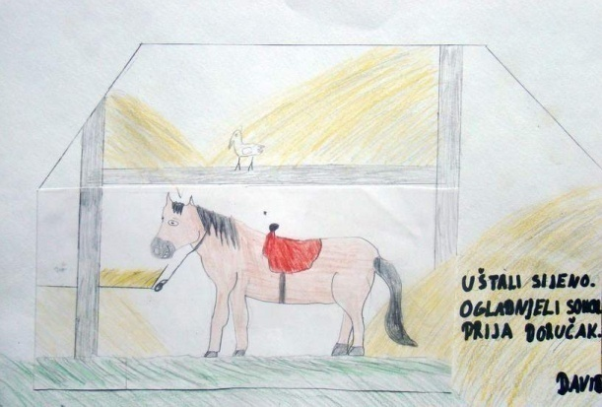
David Moguš, 4a, OŠ Novska, Novska, Croatia
Mentor: Jasna Popović Poje

*

u štali graja –
upravo se okotila
mlada kobila

hubbub in the stable –
a young mare
just gave a birth

Marija Pogorilić, Croatia

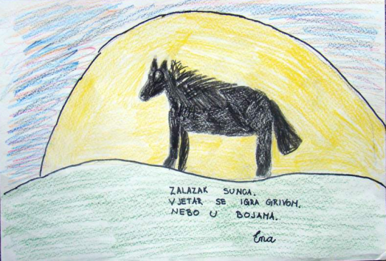

Ena Anušić, 4a, OŠ Novska, Novska, Croatia
Mentor: Jasna Popović Poje

*

chilly night
lingering heat
under his rug

prohladna noć
dugotrajna toplina
pod njegovim pokrivalom
Robert Davey, England

*

Konj pije vodo
na grivo sede metulj
nemoteča sta

A horse drinks water
on his mane sits a butterfly
of no disturbance
Translated by the author

Konj na pojilu
Na grivi sjedi leptir
-nije smetnja
Translated by the author

Rudi Stopar, Slovenia

*
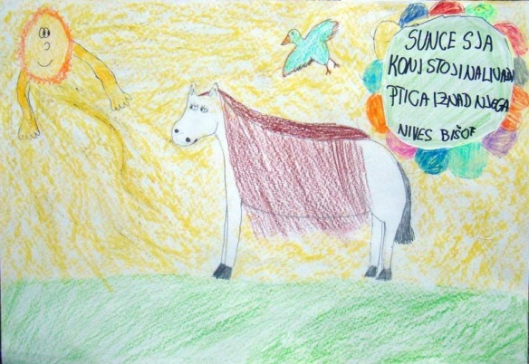
Nives Bišof, 4a, OŠ Novska, Novska, Croatia
Mentor: Jasna Popović Poje

*

zalazak sunca
između dva brijega
konj i orač

the sunset
between two hills
a horse and the plowman

Vesna Milan, Rovinj

*

horse racing
the narrator stumbles
in words

konjske trke
voditelj se spotiče
o riječi

**

fresh manure
in the military parade
well trained horses

svježe gnojivo
na vojnoj paradi
dobro obučeni konji

Rosa Clement, Brazil

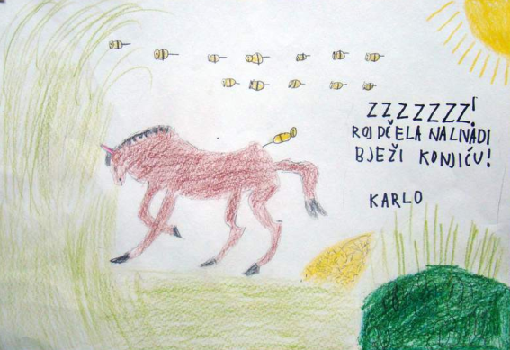
Karlo Sladojević, 4a, OŠ Novska, Novska, Croatia
Mentor: Jasna Popović Poje

*

Сјај црних сапи
и таласање гриве -
коњ у галопу.

The waving mane and
the glitter of black flank –
the galloping horse.

Razvijorena griva i
sjaj crnih slabina –
konj u galopu
Translated by the author
**

Одјек копита
и рзање тог сјајног
вранца на киши.
The echo of hooves
and the bright black horse's
neighing int he rain.

Jeka kopita
i rzanje sjajnog vranca
na kiši.
Translated by the author

Smilja Arsić, Serbia

*
nervozni rep
ošinuo dosadnu
muhu na nozi

a nervous tail
whiped a stubborn
fly on the leg

Nada Jačmenica, Croatia

*

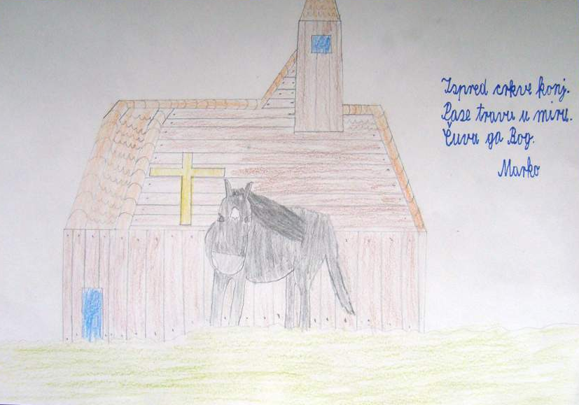
Marko Stojanović, 4a, OŠ Novska, Novska, Croatia
Mentor: Jasna Popović Poje

*

spring breeze—
a black horse waltzes
over the river

rain shivers
the wind horse
curvets and leaps

Ernesto P. Santiago, Philippines

*

νέα σελήνη πέφτει μέσα στη λίμνη - κοιτά ίππος βουβός …

new moon
falling in the lake - look, wordless steed…

mladi mjesec
uranja u jezero
pogledaj, konj bez riječi…

**

στην παλιά στέρνα
τ’ άλογο πίνει νερό -θόλωσ’ ο καθρέφτης…

at the old cistern
the horse drinks water -hazy mirror…

kod starog rezervoara
konji pije vodu
-zamagljeno ogledalo…

Zoe Savina, Greece

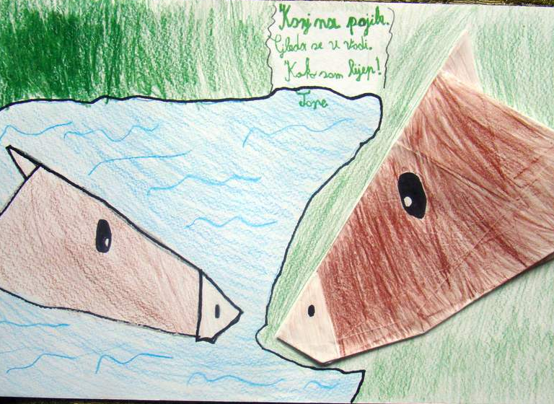

Tone Jolić, 4a, OŠ Novska, Novska, Croatia
Mentor: Jasna Popović Poje

PR
DIOGEN pro kultura
http://www.diogenpro.com

